**COMET BAY COLLEGE**

**Physics - Unit 1 - Task 3**

**Electricity Test**

**Name: SOLUTIONS Total Marks /57**

**Question 1:**

A way to “zap” your friends is to rub your feet on a carpet in summer so as to build up a charge, then you touch a friend and they get “zapped”. Why do you build up a charge when you rub your feet on carpet and what causes the “zap” when you touch your friend? **[3 marks]**

The friction between your shoes and the carpet causes electrons to transfer from one surface to another. (1 mark)

This creates a static charge on you. (1 mark)

When you touch someone, electrons move between the two of you to neutralize charge and this is the “zap”. (1 mark)

**Question 2:**

Answer the following

1. Which of the following graphs best represents a non-ohmic conductor? **[1 mark]**

Answer:

**C**

A B C D

1. Why did you select this graph? **[2 marks]**

For an Ohmic resistor; V = IR therefore R = $\frac{V}{I}$ and as R is constant, V ∝ I and you produce a straight line through (0,0). (1 mark)

In non-ohmic resistors, the resistance changes as the PD increases therefore producing a curved line. (1 mark)

Only C has a curved line.

**Question 3:**

Draw the electric field around the following two different situations.

1. **[1 mark]** b) **[1 mark]**

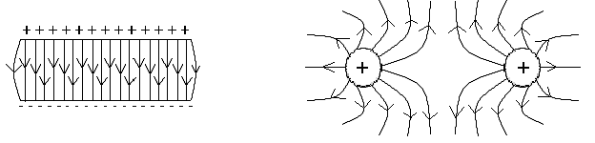

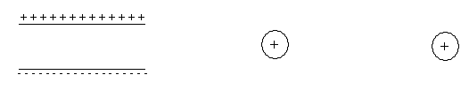

e- 🡪

current 🡨

**Question 4:**

Determine the total resistance of the 4 resistors between points P and Q in this circuit. **[4 marks]**

19 Ω

24 Ω

8.0 Ω

P

5.4 Ω

Q

Resistance of the parallel group

$\frac{1}{R_{T}}= \frac{1}{R_{1}}+ \frac{1}{R_{2}} = \frac{1}{8}+ \frac{1}{24} = \frac{4}{24}= \frac{1}{6}$ (1 mark)

RT = 6.0 Ω (1 mark)

Total Resistance

RT = R1 + R2 + R3

RT = 5.40 + 19.0 + 6.00 (1 mark)

RT = 30.4 Ω (1 mark)

**Question 5:**

A rechargeable battery was charged at a constant current of 600 mA for 9 hours. The average cell potential difference during the re-charge was 1.6 V.

1. Calculate the amount of charge that passed through the cell. **[2 marks]**

I = 600 x 10-3 A q = It

t = 9 x 60 x 60 = 32 400 s = 600 x 10-3 x 32 400 (1 mark)

V = 1.6 V = 19 440

q = 1.94 x 104 C (1 mark)

1. Calculate the amount of work done by the charging device. **[2 marks]**

W = Vq

= 1.6 x 1.94 x 104 (1 mark)

W = 3.11 x 104 J (1 mark)

**Question 6:**

Label the following circuit to show the direction of electron flow. **[1 mark]**

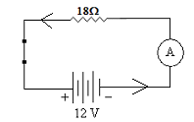

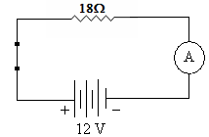

**Question 7:**

A lightning bolt contains 6.0 x 109 J of energy which is enough to power a city. If it transfers 30 C of charge to the Earth in 1.5 ms,

1. What was the potential difference produced by the lightning bolt? **[2 marks]**

W = 6 × 109 J W = Vq

q = 30 C V = (1 mark)

t = 1.5 × 10-3 s V = 2.0 × 108 V (1 mark)

q = It

1. What is the average power dissipated during the strike? **[2 marks]**

P = VI and I = $\frac{q}{t}$ therefore P = $\frac{Vq}{t}$

P = $\frac{2 × {10}^{8}× 30 }{1.5 × {10}^{-3}}$ (1 mark) P = = = 4 × 1012 W

P = 4 × 1012 W (1 mark)

**Question 8:**

A torch bulb has 2.35 Volts of potential difference applied across its contacts. What is the current flow if a charge of 16.8 Coulombs is moving across the bulb every minute? **[2 marks]**

V = 2.35 V q = It

q = 16.8 C I = q/t

t = 60 s I = (16.8 ÷ 60)

I = 0.280 A

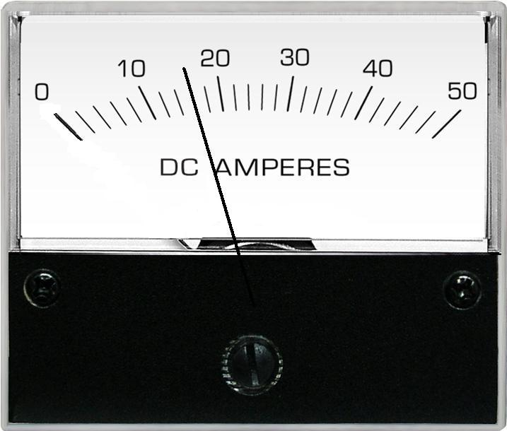**Question 9:**

The meter to the left was used during an experiment.

1. What does the meter measure? **[1 mark]**

DC Current

1. What is the value recorded on the meter? **[1 mark]**

16 (no decimal places)

1. What is the absolute error of the reading? **[1 mark]**

±1

**Question 10:**

A force of 8.50 × 10-3 N attraction is felt between two charged spheres that are 45 cm apart.

1. If one has a charge of + 0.3 μC, what is the charge on the other (given k = 9.0 × 109 N m2 C-2)?

**[3 marks]**

F =

8.5 × 10-3 =

q2 = (1 mark)

q2 = 6.375 × 10-7 C (1 mark)

as it is an attraction then q2 = − 6.375 x 10-7 C (1 mark)

1. The two spheres are then forced together (and touching) and allowed to separate to a distance of 30 cm apart. What is the force between the two spheres now? **[3 marks]**

Touching means the two spheres evenly

distribute their charge

Charge on each sphere = $\frac{+0.3+(-0.6375)}{2}$

= − 0.16875μC (1 mark)

(Note − 6.375 x 10-7 C = − 0.6375 μC)

F =

F = (1 mark)



F = 2.85 × 10-3 N repulsion (1 mark)

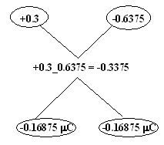

**Question 11:**

Tom was given four 3.00 Ω resistors. Draw a diagram below to show how he could connect the four resistors to give a total resistance of 4.00 Ω. **[2 marks]**

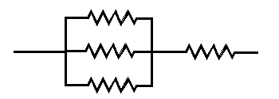

**Question 12:**

A child’s toy robot requires 4.50 V to run. The batteries supply a current of 3.00 x 102 mA and a power output of 1.35 W. Calculate the electrical resistance of the robot. **[2 marks]**

I = 0.300 A P =

P = I2R R = =

1.35 = (0.30)2 x R (1 mark) = 15 Ω

R = $\frac{1.35}{{0.3}^{2}}$

R = 15.1 Ω (1 mark) R = $\frac{V}{I}$ = $\frac{4.5}{0.3}$

= 15 Ω

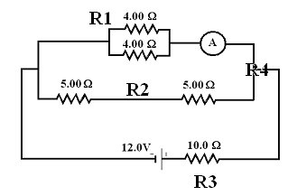**Question 13:**

Two students have set up a circuit for an investigation. The circuit diagram to the right shows a battery connected to a number of resistors.

1. Calculate the total circuit resistance. **[3 marks]**

$\frac{1}{R_{1}}= \frac{1}{4}+ \frac{1}{4}=\frac{1}{2}$ Hence R1 = 2 Ω (1 mark for having both R1 and R2)

R2 = 5 + 5 = 10 Ω

Hence R4 = 1.67 Ω (1 mark)

RT = 10 + 1.67 = 11.67 Ω (1 mark)

1. Calculate the total current through the circuit. **[2 marks]**

IT = 1.0286 (1 mark)

IT = 1.03 Amps (1 mark)

1. If the two 4.00 Ω resistors were connected in series rather than in parallel, would the reading on the ammeter increase, decrease or stay the same? Without any calculations, explain your answer.

**[3 marks]**

DECREASE V = IR, where V is constant (1 mark)

Current is inversely proportional to resistance therefore increase resistance and current decreases. (1 mark)

When 4.0 Ω resistor put in series total resistance goes from 2.0 Ω to 8.0 Ω, as resistance has increased, current has decreased so metre reads less. (1 mark)

**Question 14:**

A year 12 Physics student is trying to find a quiet place to study, so moves into a shed in the back yard. He doesn’t want to do without modern conveniences so gets a long extension cord from his parents’ place to the shed. He uses a power board to plug in all the appliances. The shed now has 240V supplied to:

* + 60W light bulb in a lamp
  + 1000W bar heater
  + 750W microwave

1. The power board has a fuse rated at 10A, does it trip if all of the appliances are turned on?

**[3 marks]**

P = 60 + 1000 + 750 P = VI

P = 1810W I = P/V

V = 240V I = 1810 ÷ 240 (1 mark)

I = ? I = 7.54 A, (1 mark)

No, the power board is OK (1 mark)

1. Calculate the resistance of the 750W microwave. **[2 marks]**

P = 750W

V = 240V

R = ? P = V2/R

R = V2/P

R = 2402/750 (1 mark)

R = 76.8 Ω (1 mark)

1. When all the devices are operating, how does the total resistance of the circuit compare to that of just the microwave? (No calculations required) **[1 mark]**

Circle the correct answer: GREATER EQUAL SMALLER

1. The element of the heater is a non - Ohmic conductor. Just after it is turned on it begins to increase in temperature and the current drawn changes. Use the Kinetic Theory to explain what happens to the current (and therefore resistance) as the element warms up to operating temperature. **[3 marks]**

Parallel RT = ( + + )-1 < individual

The current draw decreases (1 mark)

The kinetic theory explains that as the temperature increases, the kinetic energy (motion) increases (1 mark)

Electrons find it more difficult to move through the increasingly energetic particles, ie the resistance increases (1 mark)

**Question 15:**

You are given the following component.

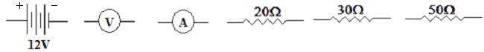

*Read all the instructions before you draw the circuit.*

Use these components to draw an electrical circuit where the 30 Ω and 20 Ω resistors are in series. Place the 50 Ω resistor in parallel with both of these resistors. Place the voltmeter to measure the potential difference of the 30 Ω resistor only and the ammeter to measure the current of the 20 Ω resistor only. The battery supplies energy to the whole circuit. **[4 marks]**

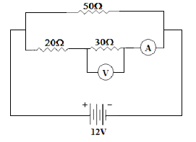

1 mark 50 Ω

1 mark 20 Ω and 30 Ω

1 mark voltmeter

1 mark ammeter (note the current is constant on that line and do not have the ammeter set up across the resistor)